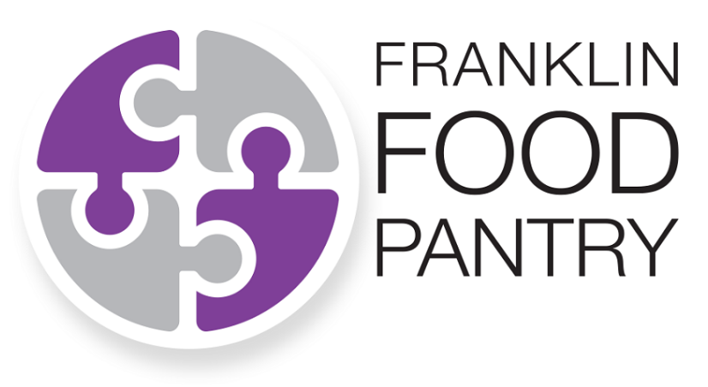

[Name of Your Company/Organization]

is holding a

**Fund Drive**

to benefit the

[Insert the dates of your Fund Drive]

**Funds**

**Monetary donations,** even a small amount, are preferred because they go a long way! The Pantry:

Can buy food from the Greater Boston Food Bank at the **best possible price –** a fraction of what it costs in the grocery store.

Can supplement food donations with more nutritious and **FRESH** food (fruits, vegetables, dairy products and meats).

Meet community need **all year long,** when food drives and fundraisers happen less frequently.

***Thank you for supporting the Franklin Food Pantry!***

Please contact [insert Drive coordinator’s name and contact information] if you have any questions.

**Monetary donations can be made by cash, check or online.**

Checks are **payable to** the **Franklin Food Pantry**

**Write your company/organization’s name** on the memo line

Give cash or check donations to [Drive coordinator inserts instructions for collection].

**Online donations can be made at www.franklinfoodpantry.org.** Please put the name of your company/organization in the **Acknowledgement Box** of the online donation form.