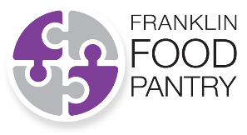 | Create A Personalized  Crowd Fundraising page!

1. Go to our Crowdfund Page  https://interland3.donorperfect.net/weblink/WebLink.aspx?name=E188424&id=34 | The page will look like this:  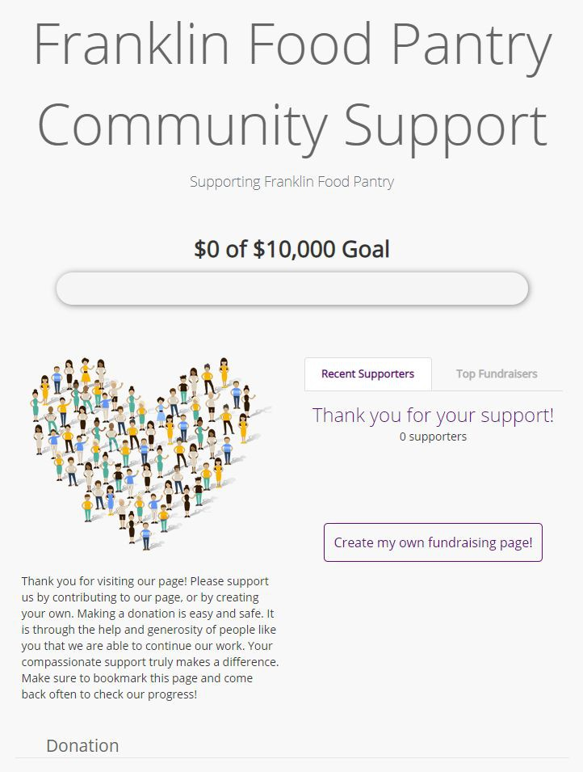

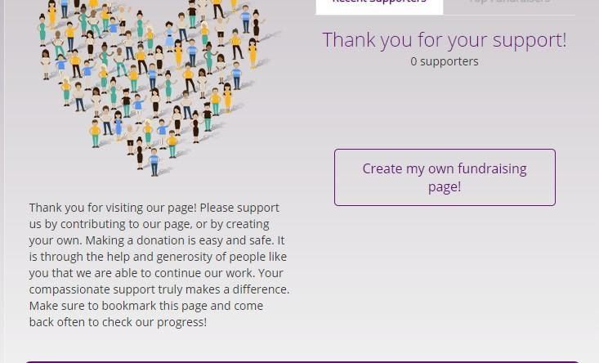
2. Scroll down until you see “Create my own fundraising page!”

3. Put your name and email address in and click “Create My Page” | 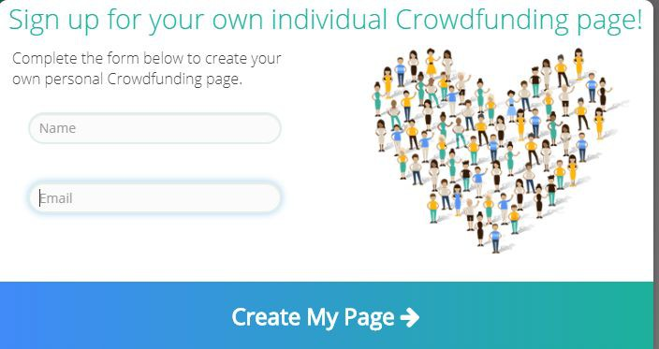

4. You will see a message confirming that your page has been created and that the links to customize and share your page have been emailed to you | 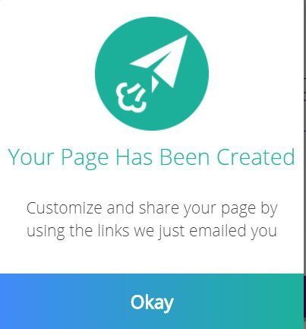

5. Open your email. You will have received two emails from mduffy@franklinfoodpantry.org
- Email One – the subject will be “Support my fundraising efforts”
- Email Two – the subject will be “Personalize your crowdfunding page – do not share link”
- Open Email Two with the subject ““Personalize your crowdfunding page – do not share link”
6. Click the “Personalize my page” button | 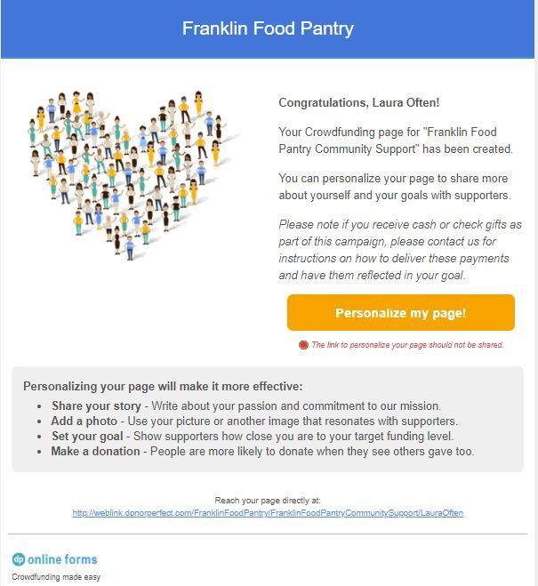

7. Where it says “$0 of $10,000” click the pencil button and change it to $500 or whatever dollar amount you would like to raise!! | 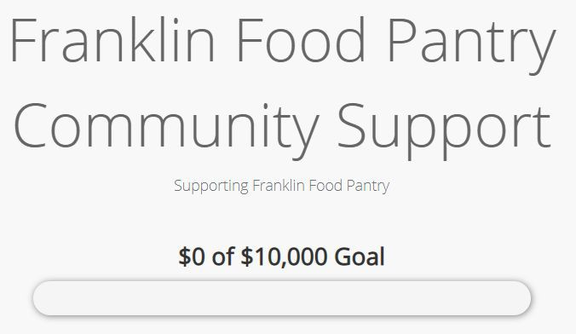

8. Click on the box where you can customize your message. Feel free to edit or leave as written. You may also use sample language below:

Thank you for visiting my page. I am choosing to raise money for the Franklin Food Pantry. Your donation allows the Food Pantry to purchase fresh food, produce and shelf stable items for over 1200 people in the Franklin area. The Franklin Food Pantry can use the donations to buy exactly what they need at heavily discounted prices from their partners. Thank you for your support. Together we can make a difference.

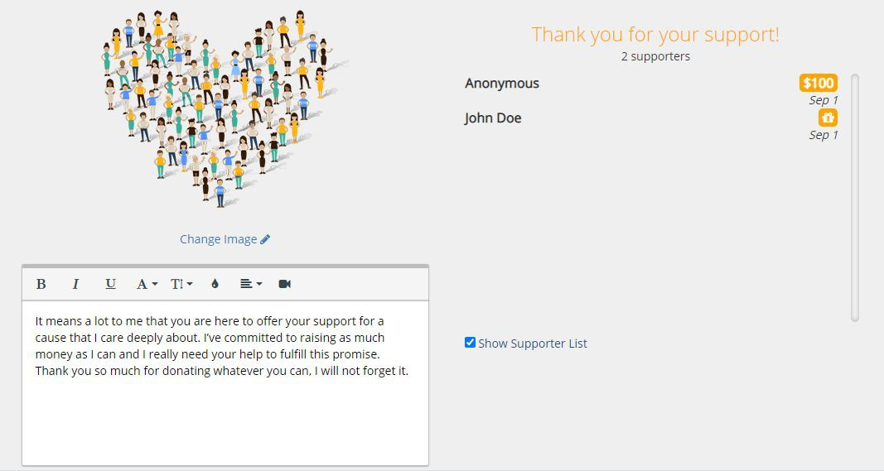

Sample language

9. Now you are ready to SAVE and PUBLISH YOUR PAGE

10. The next step is to share your page as widely as possible.
- Check your email for a message from mduffy@franklinfoodpantry.org sent to you with the subject “Support My Fundraising Effort”
- Forward the email to your friends and family so they can visit your page and donate.
- Make sure to update the subject line and delete the “Fwd” in the subject.
- Also remember to delete the reminder: “Forward this message to your family and friends!”

Here is some sample language you may use or edit:  Hello!  I’m raising money for the Franklin Food Pantry to help support the over 1200 individuals they serve. Did you know that 10% our community is experiencing food insecurity? Your donation will directly benefit your neighbors and helps The Pantry purchase fresh and nutritious food for those in need. Will you please go to my web page and donate? | 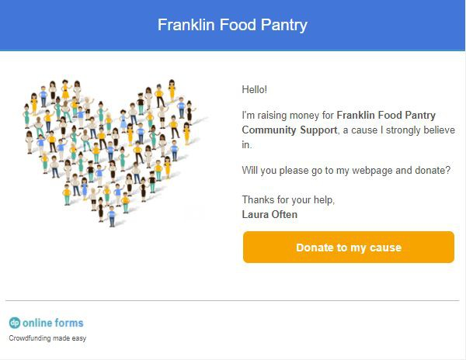

11. If you would like to share your page on social media, your personalized URL is on the bottom of the personalize your Crowdfunding page email.

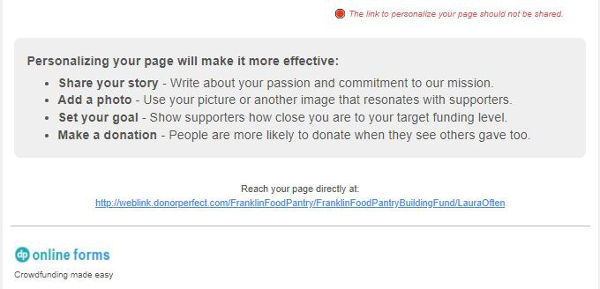

Feel free to tag the Franklin Food Pantry on Twitter @FranklinFoodPan and on Facebook @FranklinFoodPantry

12. You can also create a QR code linked to your personal crowdfunding URL (if desired). There are many ways to create a QR code and an easy and free option is through Google Chrome. You can add QR codes to flyers, keep it on your phone to easily share in person, or post on social etc.
- Open Chrome .
- Go to the page you want to share.
- Find the address bar:
  - Linux computers: On the right of the address bar, click Share QR code .
  - Windows computers: On the right of the address bar, click Share QR code .
  - Mac computers: On the right of the address bar, click Share QR code .
  - Chromebooks: Click the address bar QR code .
- You can choose to:
  - Copy the QR link.
  - Click Download to download the QR code.
  - Scan the QR code with another device's camera.

If you have questions about Crowd Fundraising please email mduffy@franklinfoodpantry.org. Thank you for your support. Everyone can make a difference in the fight against food insecurity.

