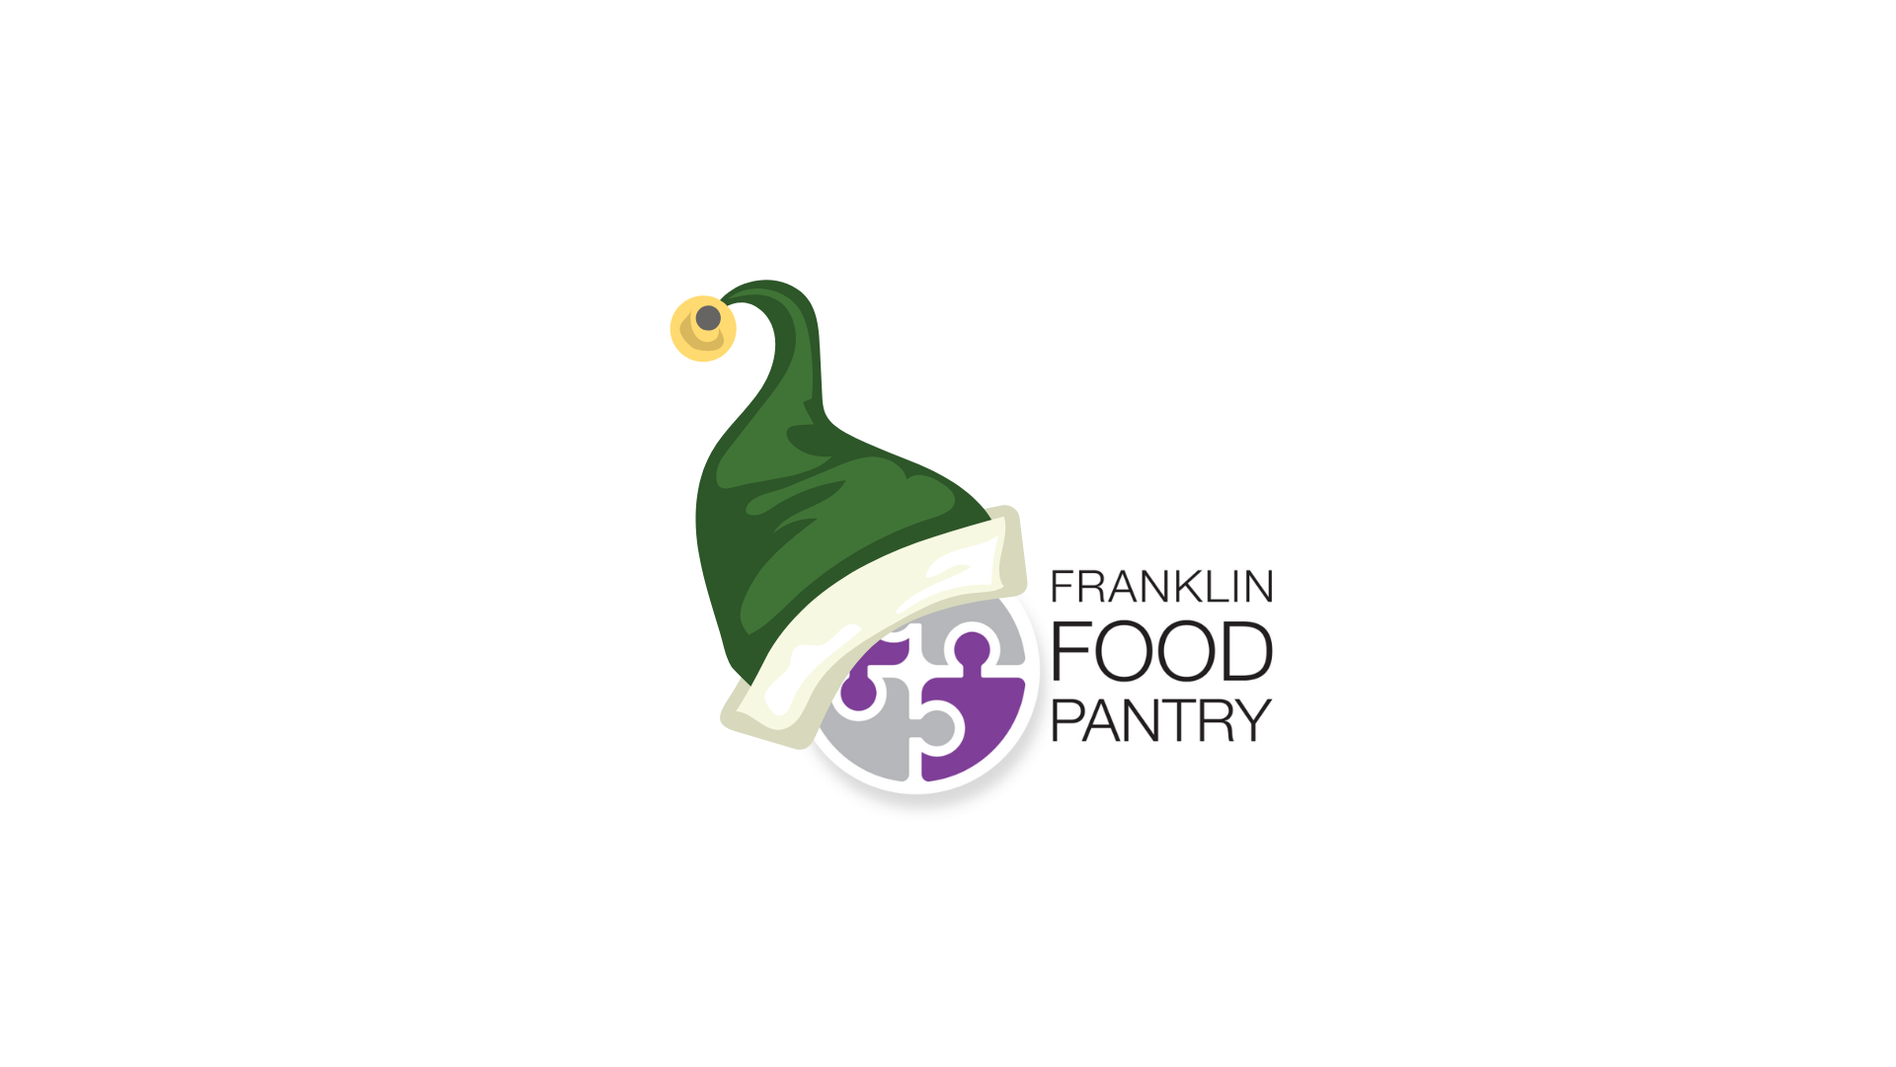
The Food Elves Campaign is The Franklin Food Pantry’s largest fundraiser of the year!
In 2022, The Elves raised over $93,000!
Food Elves are middle and high school students in the Franklin community organized by, and working with, District Parents.
Between December 1 and December 12, Food Elves pass out The Pantry’s signature purple envelopes and flyers to houses in their elementary school districts and set up their online pages to raise funds for The Pantry.
Food Elves are assigned to District Parents who help guide them through the process. District Parents are typically assigned 20 -30 students (depending on the district).
The District Parents play a very important role in the campaign! Six district parents correspond to the previous six school districts that our current middle and high school students attended:
- Jefferson Elementary School
- Parmenter Elementary School
- Oak Street Elementary School
- Hellen Keller Elementary School
- John F. Kennedy Elementary School
- Davis Thayer Elementary School (now closed but students who attended still canvas in the Davis Thayer district)
What Does a District Parent do?
- You are the direct contact for the Elves who sign up in your district.
- You assign streets to the Elves (The Pantry will provide street maps corresponding to elementary school districts).
  - Elves indicate their Elementary Schools when they sign up.
- You help the Elves organize kick-off activities in the neighborhood....
  - Distribute lawn signs
  - Oversee envelope and flyer distribution
  - Help them to say thank you
- You sign off on community service hours (The Pantry will provide you with forms).
  - In-person Elves get 12 hours
  - Online Only Elves get 10 hours
- You collect and deliver checks to The Pantry.
Elves can also choose to fund raise online only – you will not have any responsibilities to these Elves!
The Pantry will provide a staff contact to help District Parents.
Time commitment: November 1 – December 15

- 1 hour meeting with Pantry and other District Parents for kickoff
- Meet with Food Elves to assign streets (in person at your home), give out lawn signs and envelopes
- Answer Food Elf questions via email
- Collect envelopes from Food Elves
- Return envelopes to The Pantry

